**U.S. Naval Hospital Yokosuka**

**Japanese Fellowship Program**

**2024-2025**

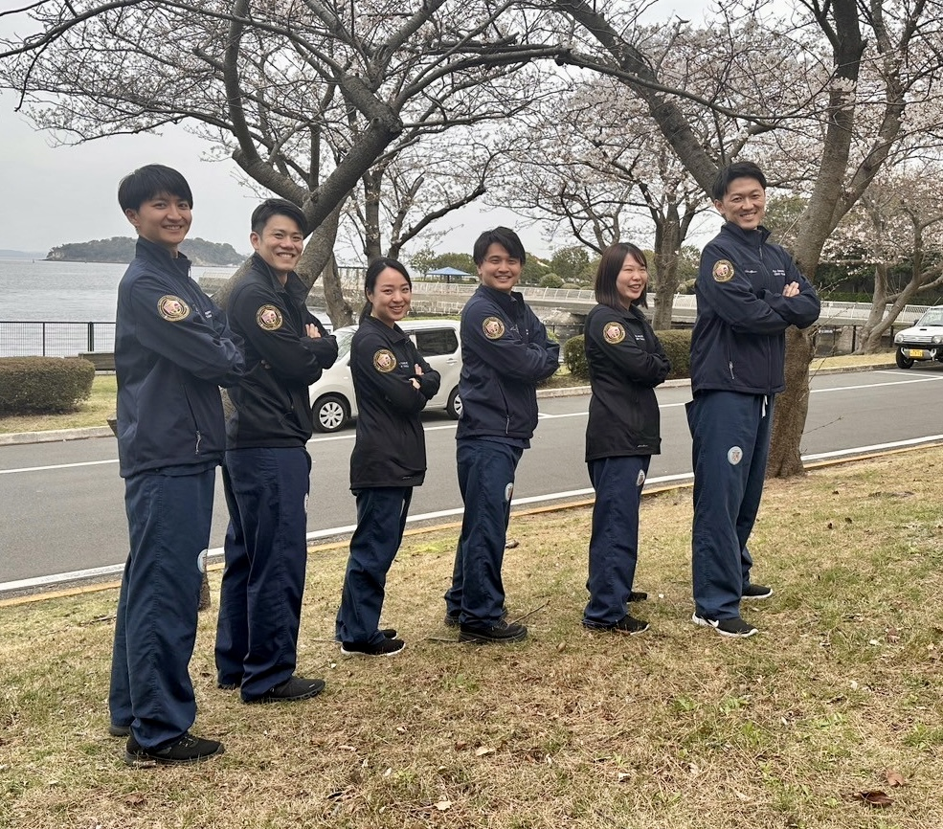

### Program Directors’ Welcome

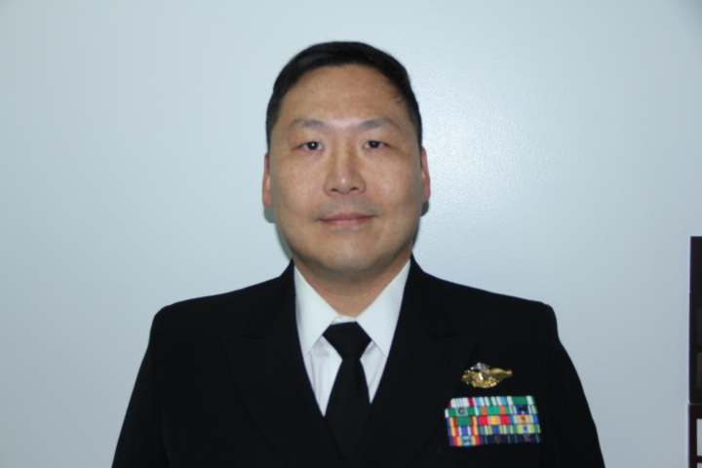 **Dr. Benjamin Chi, CDR, MC, USNH YOKOSUKA**

**Executive Program Director**

Thank you for your interest in the Japanese Fellowship

Program. This program is an incredible platform for building

relationships that improves the care for our patients and will help

you grow as a physician. In just one year, I have seen fellows gain

experiences, associations and friendships that benefit our mutual

missions. There is so much that can only be experienced by

participating in the program as a fellow, so please submit your

application! I look forward to meeting you and answering any of your

questions.

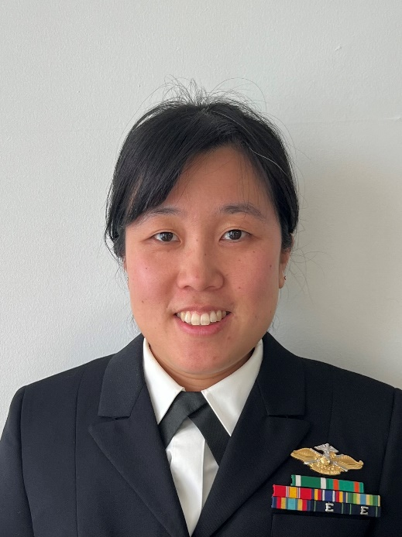

**Dr. Angela Zah, LCDR, MC, USNH YOKOSUKA**

**Associate Program Director**

Thank you for your interest the Japanese Fellowship program at Yokosuka. Our program aims to give fellows exposure to a different healthcare system and medical education experience unique from what they have experienced in Japan. It is also an opportunity build lifelong friendships and partnerships. We hope this experience will open your eyes to the challenges we face providing healthcare in a culture different from our own.

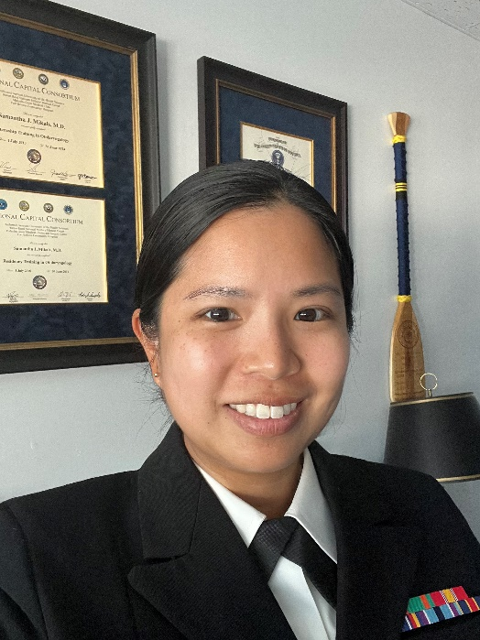**Dr. Samantha Mikals, LCDR, MC, USNH YOKOSUKA**

**Associate Program Director**

Welcome to USNH Yokosuka and thank you for your interest in our program! We have developed an academic program that focuses on hands on practice of your Medical English through presentations modeled after US residencies, OSCEs, mock residency interviews and real patient encounters. Our goal is to provide an experience that will help you meet your future goals. I will be passing the torch to a new Associate Director during the first quarter of this academic year and ensuring continued success of our program!

### Fellow Expectations and Roles

Fellows are a critical and integral in the operations of USNH Yokosuka. Since 1952, the Fellowship has forged a partnership between Japanese and American healthcare professionals. The primary mission of the Fellowship is to educate fellows about Western medicine, evidence-based practice, and patient-centered care. A secondary mission is for fellows to act as a liaison and translator with Japanese hospitals during the transfer of acutely ill American patients that exceed the capabilities of USNH Yokosuka. The liaison role can be difficult as it bridges gaps in cultures and standards of care, but it I an immensely rewarding experience and meaningful to the American patients.

Communication and Cultural Differences

The staff of the Naval Hospital speak English as do most of the patients. Most of the staff will be stationed in Japan for two to three years, during which time some USNH staff take Japanese language courses but few become fluent. Rarely are the USNH physicians proficient enough to communicate patient information in Japanese. Fellows are constantly challenged to speak English as well as understand cultural differences between the Japanese and USNH patients. Military family and Service members come from all over the world – not just from the U.S. – providing significant racial, language, religious, and cultural diversity that you may not be accustomed to when practicing medicine in Japan. USNH staff are always available and happy to assist with questions about a particular problem regarding English (conversational, medical, or military.) Although you may question your English ability, you will be pleasantly surprised to see just how quickly your proficiency improves during your time here.

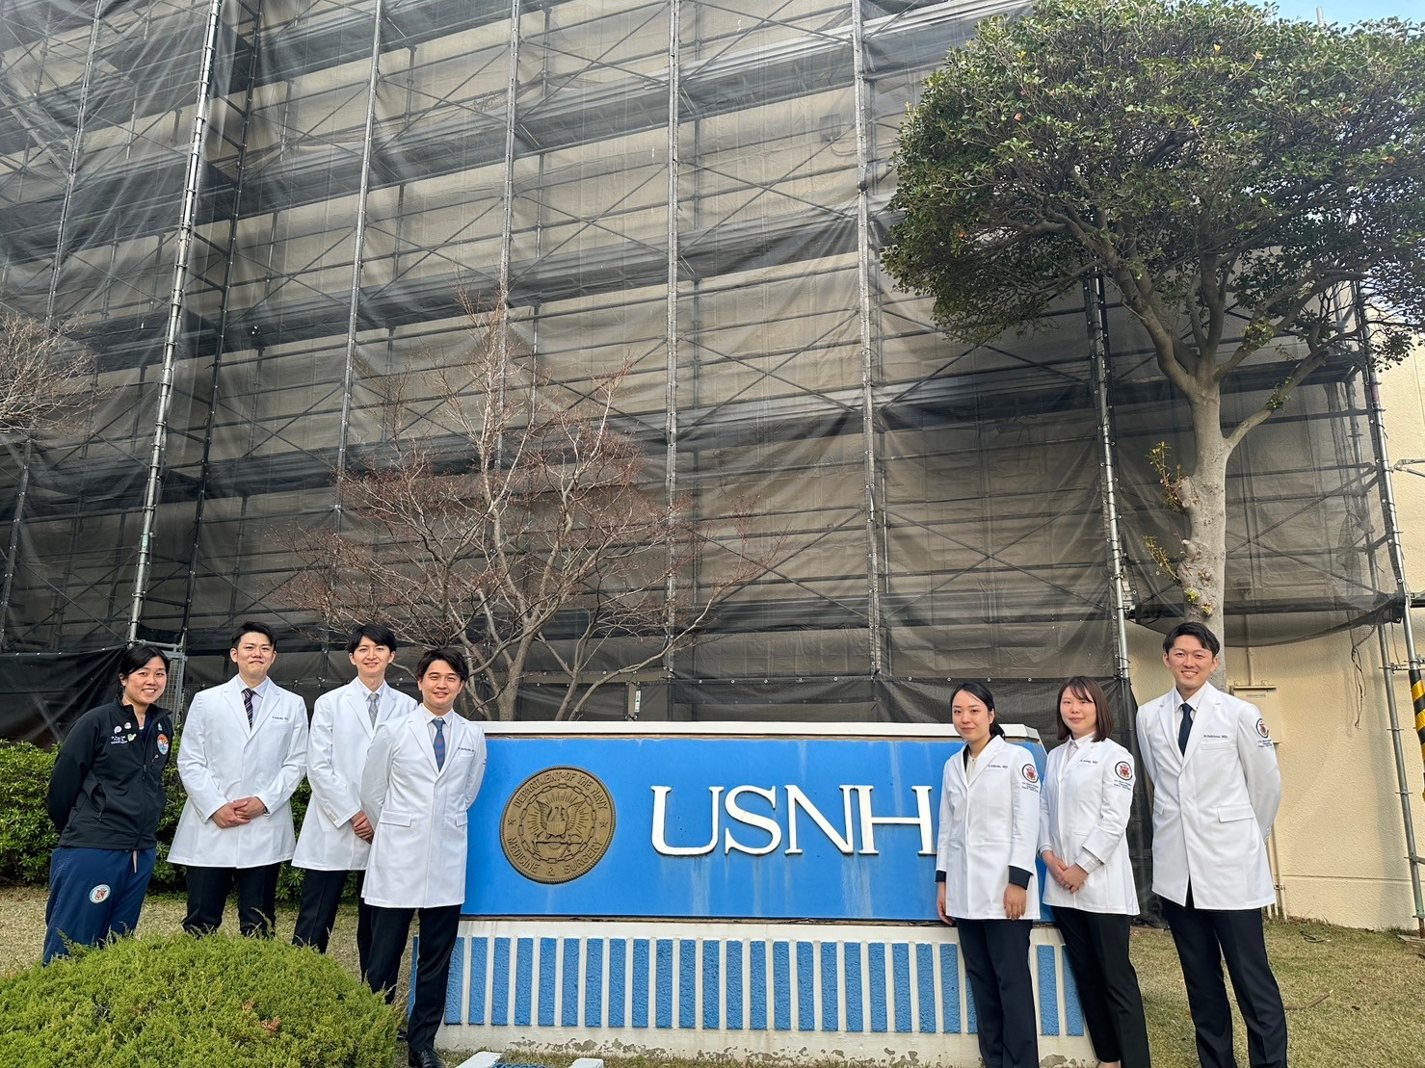

## **Duty**

Also known as "on call.", fellows are on duty on average every sixth day. The fellow on duty is responsible for coordinating and assisting with transfers of USNH patients to

Japanese hospitals. This responsibility is critical to safe patient care at USNH since fellows are

the link between USNH physicians and Japanese physicians accepting the patient for transfer.

Most patient transfers occur during normal daytime business hours, but they can also happen

overnight and on weekends.

Duty is covered seven days a week, including holidays. Some days there are no transfers, and the fellow on duty can use this free time to do rotations, participate in academics, study, or sleep if after hours. Two on-call fellows must be available for transfer every day. The fellow on duty (1st on call) must report to the hospital within 15 minutes if called in for a transfer. The fellow on duty typically stays in the duty room in the hospital overnight. The fellow on back-up call (2nd on call) should be prepared to take other transfers when the other fellow (1st on call) is already called in.

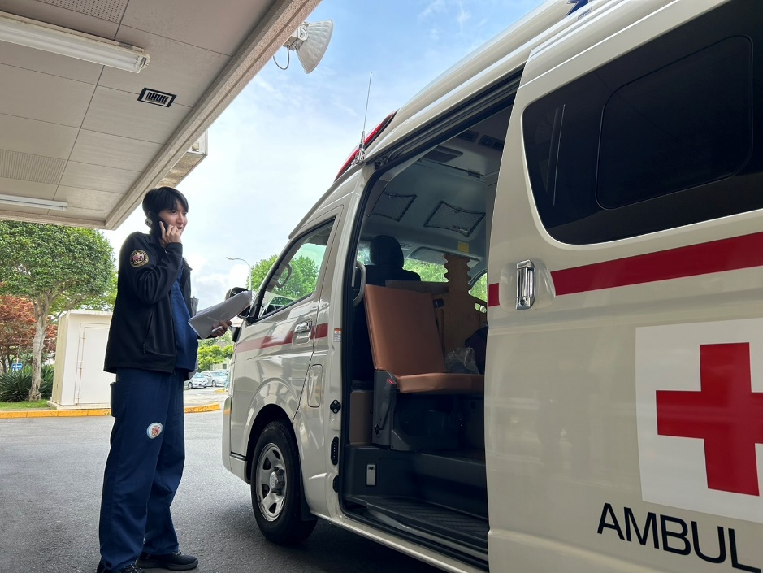

**Clinical Rotations**

Although fellows are not credentialed to independently care for patients at USNH, they are active participants during rotations in clinic, the operating room and the emergency room. Fellows are expected to have frequent opportunities to practice history taking, physical exams, presentations, note taking, and can participate in procedures as an assistant under direct supervision of credentialed health care providers in accordance with the laws and regulations of the United States. More details are provided below.

### Rotation Schedules and Curriculum

All fellows can rotate through various departments. The rotation schedule can be tailored to

each fellow depending on their individual career goals. The fellows are also provided time to do overseas electives/observerships should they desire. The available departments for rotation are listed below:

|  |  |
| --- | --- |
| Internal Medicine | Family Medicine |
| Pediatrics | Obstetrics/Gynecology |
| General Surgery | Emergency Medicine |
| Ophthalmology | Urology |
| Otolaryngology/ENT | Radiology |
| Orthopedic Surgery | Anesthesiology |
| Neurology | Psychiatry |
| Dermatology | Pathology |
| Operational Medicine | Occupational Health |

子供を抱いている女性

低い精度で自動的に生成された説明病室にいる人たち

### Teaching Conferences and Educational Opportunities

The didactics of the USNH Yokosuka Fellowship Program is one of the greatest strengths of the program. There are several different formats education is provided. Some, such as noon conferences and joint conferences, are fellow-led whereas others, such as provider lectures, are staff-led or in a group discussion format. Fellows are also provided with the opportunity to obtain various life support certifications.

## Noon conferences

## Noon conferences take place from 1200 to 1300 on Mon, Wed, Fri each week and are the cornerstone of the educational endeavors available to the fellows. These conferences happen in the form of Morning reports, Oral Boards, and Grand Rounds presentations, OSCEs, Provider Lectures, Motivational Interview Simulations, and Residency/Fellowship Mock Interviews.

## **Morning Reports/Oral Boards/Grand Rounds Presentations**

## Fellows have ample opportunity to practice presenting clinical cases in Morning Report style as they would during residency. Oral Boards is also another unique presentation style common in surgical residencies in the U.S. and fellows have a chance to experience what it is like to sit in one through these sessions. All fellows undertake a Grand Rounds Presentation given in the Command Auditorium near the end of the year. This 30-minute lecture is open to all providers and staff in the Command. An example of a topic covered in the class of 2025 was “Differences in Medical Education between the U.S. and Japan”, which stimulated a great discussion to better understand the differences in medical training between the two nations.

## 

## **OSCEs**

## Fellows have the opportunity to do OSCEs and receive feedback from the providers at the USNH. During the 2024-2025 year, we were able to do 5 different OSCE scenarios with providers as part of the noon conference curriculum. Each was followed by extensive feedback by 2-3 providers on how to improve history taking, physical examination, and patient counselling skills.

## **Provider Lectures**

These lectures provided by USNH physicians and staff cover core topics that range from clinical medicine to resident wellness, which are all relevant in pursuing a career as a physician in the U.S. Additionally, guest lecturers who practice in various subspecialties from other bases as well as visiting Fellowship alumni are often invited to give talks. These lectures help to deepen the fellow’s understanding of American medicine and better prepare them to practice medicine in the U.S.

## **Motivational Interview Simulations and Residency/Fellowship Mock Interviews**

Other practical didactic sessions include motivational interviewing simulation session provided by a trained psychologist and residency/fellowship mock interviews offered in the form of in-person and virtual, both of which are immensely helpful for those that are applying for residency/fellowship.

Of note, didactics available to the fellows change each year. The above is an example of the opportunities that were available in the year of 2024-2025. The Academics Chief will coordinate with the associate program directors and providers to create a curriculum at the beginning of the year.

## Transfer conference

This monthly case discussion centers on reviewing transfer cases from the previous month. In this conference, fellows report all the cases they experienced. This discussion is aimed at identifying issues that contributed to the outcome of the transfer to prevent similar occurrences in the future. This discussion is also pivotal in fostering good relationships between host nation hospitals and USNH.

## Joint Conferences

Joint conferences are opportunities for providers at USNH and local hospitals to collaborate and share aspects of each other’s practices. USNH and the local hospitals alternate hosting the conferences.

The Japanese fellows are expected to present on the USNH side. It is a great opportunity to practice formal, academic-conference-level presentations in English in front of USNH and local Japanese hospital providers. Fellows are expected to thoroughly know the patients and all aspects of the cases they present in order to field questions from the audience. Presenters will work closely with a USNH attending involved with the case while preparing for the conference.

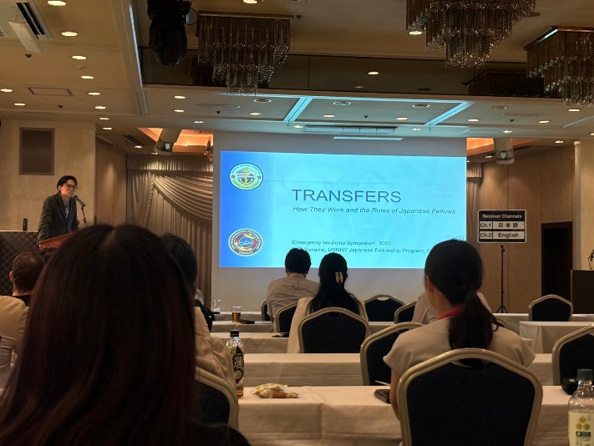

Life Support Certifications

Basic Life Support (BLS), Advanced Cardiac Life Support (ACLS), Pediatric Advanced Life Support (PALS), Advanced Trauma Life Support (ATLS), the Neonatal Resuscitation Program (NRP), and Neonatal Transport Education (STABLE) are available free of charge to all interested fellows.

### Miscellaneous

Housing

All fellows need to find off-base housing.

## On-base Privileges

Fellows have full access to the base and may come and go freely. They also have access to the Officers’ Club, Purdy Gym, Fleet Recreation Center, Base theater, Bowling alley, restaurants (Taco Bell, Popeyes, Starbucks, McDonald etc), and base sports fields and courts. If properly registered, the fellows may ride bicycles on the base.

## Military Medicine

Fellows have the unique opportunity to be involved in disaster drills with the Japanese Maritime Self Defense Force and local hospitals. In addition to working as a liaison and translator, fellows get exposure to dive chambers, medical aircraft, and other specialized medical equipment unique to the military in Yokosuka several times a year.

American patients are transported back to the United States via a Critical Care Air Transport Team, which converts military aircraft into an intensive care unit on par with hospital-based facilities. Fellows are integral to these transfers since the patients are complicated and usually admitted to Japanese ICU at the time of transfer. Involvement in these cases is highly sought after given the critical condition of the patient and the

unique capabilities of the critical care team.

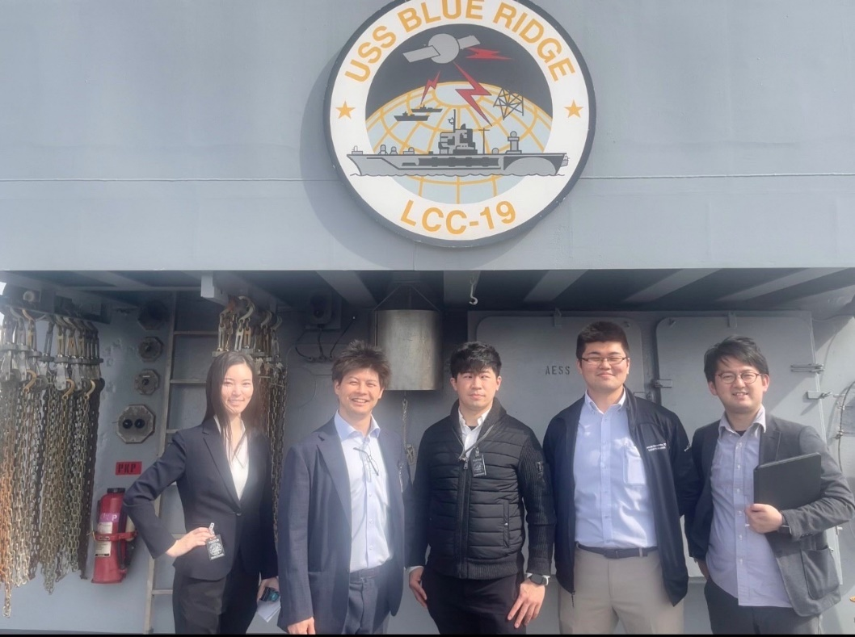

**FAQ**

Q. *Is an Externship necessary to apply for the Fellowship program?*

A. Externship is not required for application. However, we strongly recommend applicants to participate in the Externship program. Through this 5-day program, you can rotate in several departments of our hospital, ask questions to current fellows, and get to know more about life in USNH. You are also given an opportunity to do an English case presentation that not only gives you a chance to introduce yourself to the USNH doctors, but also receive feedback from the audience. It is also a good opportunity to meet other externs with similar aspirations since there are 4-6 participants participating during the same week. During the externship, a casual dinner party is held at a local Izakaya or restaurant. This is a time for participants to have a relaxed conversation with providers and current fellows.

Q. *What kind of physicians apply to this program?*

A. Physicians who vary in PGY and interests apply to our program each year. In the class of 2025, we have three PGY3s, a PGY4, PGY6 (board-certified OBGYN provider), and PGY9 (board-certified colorectal surgeon) physician. Some apply to residency/fellowship and some have just started to take USMLE, and some apply to Master of Public Health, Ministry of health, or other unique positions.

Q. *What is an average day schedule for Fellows?*

A. 0700-1200: Clinical Rotations

1200-1300: Lunch/Noon conference

1300-1600: Clinical Rotations

If you are “On-call”, you may have to transfer patients to a Japanese hospital at any time at which time you would be excused from rotations.

Q. *Can Fellows buy food in the hospital?*

A. Yes, the hospital has a cafeteria (Galley), a commissary store (NEX mini mart), and coffee shop (Seattle’s Best Coffee), where Fellows can get food.

Q. *What kind of patients do we encounter in clinic?*

A. Most patients are people working in the Navy and their families.

Sometimes we also treat veterans, civilian contractors or pregnant women living on other US military bases with no labor facility (ex. Atsugi, Iwakuni, Sasebo etc).

Q. *How many transfers do fellows experience in USNH Yokosuka?*

A. Since our hospital cannot perform certain tests or procedures, we often need to send patients to host nation hospitals for them. Number of total transfers vary from year to year but they are within the range of 160-240 cases/year.

Examples of cases are shown below:

* ex.1) a patient suspected of cerebral infarction; transferred to have an MRI and to have further treatment if needed
* ex.2) a patient presented with chest pain; transferred to have CAG and further investigation and treatment
* ex.3) a GA32weeks woman diagnosed w/ severe preeclampsia; transferred to have cesarean delivery and NICU care subsequently

*Labor of patients under GA35 weeks cannot be managed at USNH Yokosuka

Q. *Can Fellows use any study materials in the hospital?*

A. Yes, fellows are free to use the library in the hospital. Moreover, we have access to other resources such as UpToDate, Dynamed, NEJM and so on.

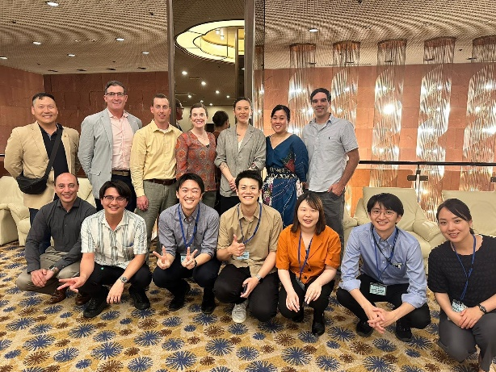図書館の机でパソコンをする男性

Q. *What are the outcomes after graduation from this program?*

A. It depends on the year. For instance, in the class of 2024, two fellows matched to IM and Neurology residency, one fellow acquired a research position in the U.S., three fellows have resumed working at a Japanese hospital with the hopes of applying to residency/fellowship soon. In the class of 2025, two fellows are applying to residency and four are preparing to apply the following year.

Q. *What do fellows do after work?*

A. Study English, USMLE, or prepare for the match. We are also allowed to use this time for moonlighting. Some go out with providers or spend quality time with family.

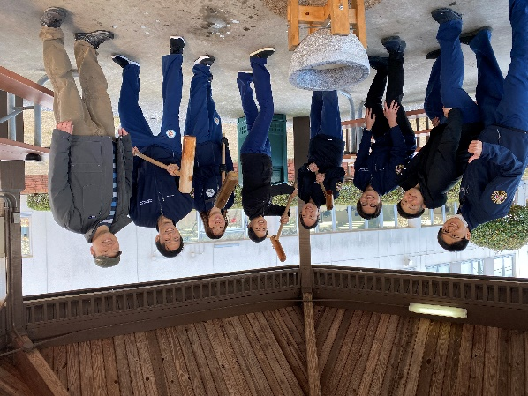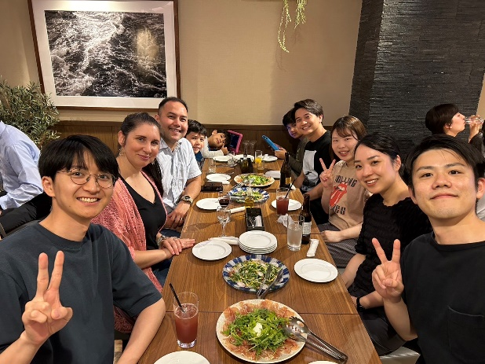

Q. *Do Fellows have holidays?*

A. Yes. We follow American national holidays. Many of our fondest memories are those outside of work where we enjoyed festivities with the providers. Some notable ones include Easter and Halloween.

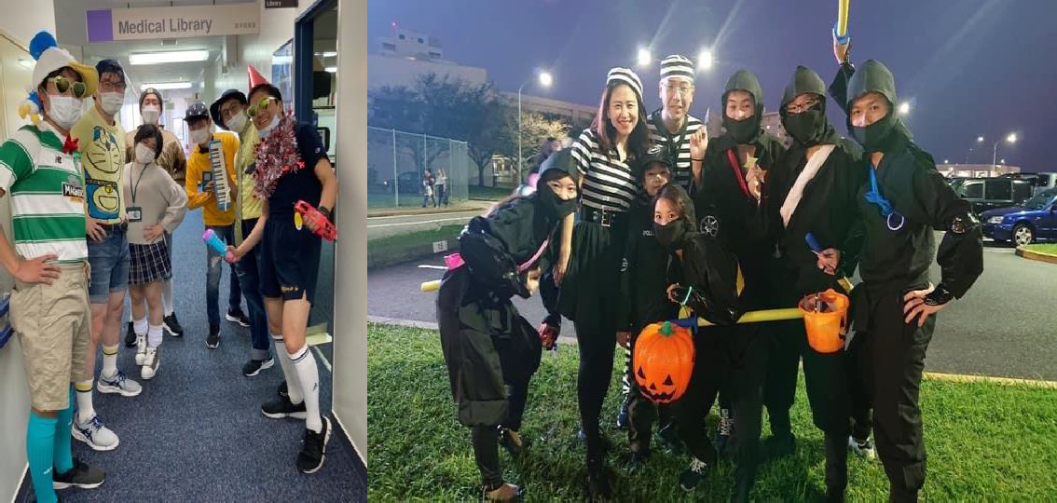

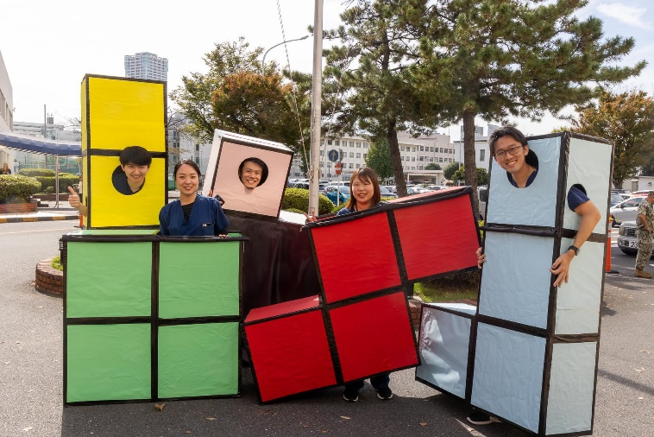

Q. *Do Fellows have an opportunity to contact alumni?*

A. Yes, fellows have access to the alumni member list provided by the alumni association. Each year, some alumni visit the hospital and give lectures as well. These events foster the bond across generations and strengthen the alumni network of this fellowship program. They are also opportunities to listen to actual voices of alumni that have actually experienced getting a residency, fellowship, or attending position in the U.S.

### 

### 

### Alumni Voices

*“The experience as a Japanese fellow at US Naval Hospital Yokosuka perfectly prepared me for my upcoming residency in the U.S. Transfers can be quite a challenge sometimes, but they also instilled in me a great sense of advocacy, teamworking, and dedication for patients. Hanging out with my colleagues and mentors, whom I can proudly call “friends”, brought me so many exciting and fun memories, as well as a huge boost for my English proficiency. If you are on the fence, just come and join our externship or open house, and you will see what I meant.!”*

* **Yuya Takahashi**, M.D. Class of 2022

*“Numerous, fabulous memories always come back to my mind with the scent of salty sea breeze just by closing my eyes. Here you are in a unique position to connect two countries with meticulous communication and knowledge as a JA fellow. But also you come here to flesh out yourself to achieve your promising career. Are you a bit nervous ? No worries. The crews here always support you. Your colleagues will give you a helping hand anytime. Trust me. You are on the right track. It's not that long until you realize that you are making progress in your variety of skills. This is the best place to get ready for your coming adventure in the U.S.”*

* **Ryoichi Inoue**, M.D. Class of 2022

*"Being the liaison between USNH Yokosuka and the Japanese hospitals has been one of the most unique and valuable experiences as a physician who aspires career in the U.S. As a Japanese Fellow at USNH Yokosuka, you will meet with the best colleagues you can ever have, and your Program Directors and the American physicians will help you achieve your future goal. After graduation, this Fellowship Program will allow you a smooth transition to the U.S. which would not have happened elsewhere. You will face hardships, but it will definitely be an unforgettable experience that you will cherish for a lifetime!"*

* **Kazuki Toda**, M.D. Class of 2022

*"This fellow ship program will brought me such an extraordinary experience that helped me to develop my career. Being the middle person between US and Japan taught me what American style medicine is, and also I could have a better grasp of the medical system in our country. Throughout this experience I could find not only amazing mentors but also lifelong soul mates."*

* **Daiki Debun**, M.D. Class of 2022

*"The one year in USNH Yokosuka was like a precious dream for me. I had initially worked as an internal medicine resident in Japan, and it was my first experience in the U.S. medical field, realizing what it was like to work as a doctor in the U.S. My rotations included internal medicine, neurology, obstetrics and gynecology, pediatrics, pathology, dermatology, and various other departments. I exposed myself to multiple aspects of U.S. medicine by participating in surgeries, grossing specimens in the laboratory, taking histories and physical examinations, practicing presentations, and so on... In addition, thanks to the other five fellows' and the USNH staff's strong motivation and support, I was able to pass USMLE STEP1 and OET, starting my path as a pathologist in the U.S. I believe that USNH has been the place where the fellows develop both professionally and personally. I genuinely appreciate and miss you so much, USNH!*

* **Yoriko Nishikawa**, M.D. Class of 2022

*It was a fantastic year that I spent at USNH Yokosuka. You can experience US-style medicine in each clinical rotation, hone your knowledge at daily academic lectures, and learn a lot from the differences in medicine and culture between the US and Japan during emergency transfers. You may face many challenges; however, I guarantee there is no better place in Japan to improve your English and take the next step toward your career goal than here.*

* **Toshiaki Takahashi**, M.D. Class of 2022

